

**Ahsania Mission University of Science & Technology**

**Lab Report**

**Lab No:** 02

**Course Code:** CSE2202

**Course Title:** Computer Algorithm Sessional.

**Submitted By:**

Afrin Nahrin Nipu

ID: 1012320005101025

1st Batch, 2nd Year, 2nd Semester

Department of Computer science and Engineering,

Ahsania Mission University of Science & Technology

**Submitted To:**

Md. Fahim Faisal

Lecturer,

Department of Computer science and Engineering,

Ahsania Mission University of Science & Technology

**Task No.:** 01

**Problem Statement:** Integer Multiplication and Use the time reading function for time calculation.

**Source Code:**

#include <iostream>

#include <cstring>

using namespace std;

#define MAX 200

#include<ctime>

class BigIntMultiplication

{

private:

int numA[MAX], numB[MAX], result[MAX];

int lenA, lenB;

public:

BigIntMultiplication()

{

memset(numA, 0, sizeof(numA));

memset(numB, 0, sizeof(numB));

memset(result, 0, sizeof(result));

lenA = lenB = 0;

}

void storeNumber(int num, int arr[], int &length)

{

while (num > 0)

{

arr[length++] = num % 10;

num /= 10;

}

}

void multiply(int A, int B)

{

if (A == 0 || B == 0)

{

cout << "0" << endl;

return;

}

storeNumber(A, numA, lenA);

storeNumber(B, numB, lenB);

for (int i = 0; i < lenA; i++)

{

for (int j = 0; j < lenB; j++)

{

result[i + j] += numA[i] * numB[j];

result[i + j + 1] += result[i + j] / 10;

result[i + j] %= 10;

}

}

printResult();

}

void printResult()

{

int lenResult = lenA + lenB;

while (lenResult > 1 && result[lenResult - 1] == 0)

{

lenResult--;

}

for (int i = lenResult - 1; i >= 0; i--)

{

cout << result[i];

}

cout << endl;

}

};

int main()

{

int A, B;

cout << "Enter two integers: ";

cin >> A >> B;

BigIntMultiplication multiplier;

cout << "Product: ";

clock_t time1 = clock();

multiplier.multiply(A, B);

clock_t time2 = clock();

double time_spand = double(double(time2-time1)/ CLOCKS_PER_SEC);

cout<<"\n time required: "<<time_spand;

return 0;}

**Output:** 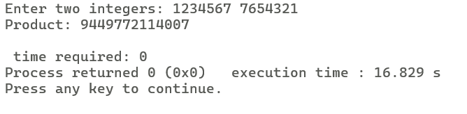 **Task No.:** 02

**Problem Statement:** Using Karatsuba Multiplication algorithm write a program that multiply two Integer number.

**Source Code:**

#include <iostream>

#include <cmath>

#include<ctime>

using namespace std;

int power(int x, int n) {

return pow(10, n);

}

int karatsuba(int x, int y) {

if (x < 10 || y < 10) {

return x * y;

}

int n = max(log10(x) + 1, log10(y) + 1);

int half = n / 2;

int a = x / power(10, half);

int b = x % power(10, half);

int c = y / power(10, half);

int d = y % power(10, half);

int ac = karatsuba(a, c);

int bd = karatsuba(b, d);

int ad_plus_bc = karatsuba(a + b, c + d) - ac - bd;

return ac * power(10, 2 * half) + ad_plus_bc * power(10, half) + bd;

}

int main() {

int num1, num2;

cout<<" Enter two Integer number: ";

cin>>num1>>num2;

clock_t time1 = clock();

int result = karatsuba(num1, num2);

clock_t time2 = clock();

cout << "Result: " << result << endl;

double time_spand = double(double(time2-time1)/ CLOCKS_PER_SEC);

cout<<"\n time required: "<<time_spand;

return 0;

}

**Output:**

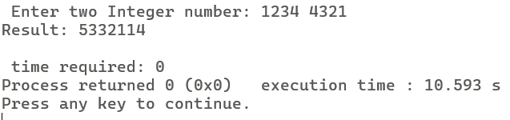

**Task No.:** 03

**Problem Statement:** Implement the insertion sort algorithm for sorting one dimensional array.

**Source Code:**

#include <iostream>

using namespace std;

void insertionSort(int arr[], int n) {

for (int i = 1; i < n; i++) {

int key = arr[i];

int j = i - 1;

while (j >= 0 && arr[j] > key) {

arr[j + 1] = arr[j];

j = j - 1;

}

arr[j + 1] = key;

}

}

void printArray(int arr[], int n) {

for (int i = 0; i < n; i++) {

cout << arr[i] << " ";

}

cout << endl;

}

int main() {

int arr[] = {12, 11, 13, 5, 6};

int n = sizeof(arr) / sizeof(arr[0]);

cout << "Original array: ";

printArray(arr, n);

insertionSort(arr, n);

cout << "Sorted array: ";

printArray(arr, n);

return 0;}

**Output:** 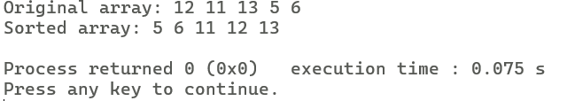

**Task No.:** 04

**Problem Statement:** Write down a program that **multiplies two large non-negative integers** represented as strings. Because int and long int has memory limitations.

**Source Code:**

#include <iostream>

#include <string>

using namespace std;

int main()

{

string X, Y;

while (cin >> X >> Y)

{

string product = "0";

int lenX = X.length();

int lenY = Y.length();

string result(lenX + lenY, '0');

for (int i = lenX - 1; i >= 0; --i)

{

for (int j = lenY - 1; j >= 0; --j)

{

int mul = (X[i] - '0') * (Y[j] - '0');

int sum = mul + (result[i + j + 1] - '0');

result[i + j + 1] = (sum % 10) + '0';

result[i + j] += (sum / 10);

}

}

int start = 0;

while (start < result.length() && result[start] == '0')

{

start++;

}

if (start == result.length())

{

cout << "0";

}

else

{

for (int i = start; i < result.length(); i++)

{

cout << result[i];

}

}

cout << endl;

}

return 0;

}

**Output:**

